TITLE 1: TABLES AND GRAPHS

|  |  |  |  |  |  |
| --- | --- | --- | --- | --- | --- |
| **Group Statistics** | | | | | |
|  | GROUP | N | Mean | Std. Deviation | Std. Error Mean |
| ACCURACY | GROUP | 10 | 87.9500 | 3.58802 | 1.13463 |
| ACCURACY | 10 | 87.6400 | 1.93861 | .61304 |

|  |  |  |  |  |  |  |  |  |  |  |
| --- | --- | --- | --- | --- | --- | --- | --- | --- | --- | --- |
| **Independent Samples Test** | | | | | | | | | | |
|  | | Levene's Test for Equality of Variances | | t-test for Equality of Means | | | | | | |
| F | Sig. | t | df | Sig. (2-tailed) | Mean Difference | Std. Error Difference | 95% Confidence Interval of the Difference | |
| Lower | Upper |
| ACCURACY | Equal variances assumed | 2.568 | .126 | .240 | 18 | .813 | .31000 | 1.28966 | -2.39947 | 3.01947 |
| Equal variances not assumed |  |  | .240 | 13.842 | .814 | .31000 | 1.28966 | -2.45900 | 3.07900 |

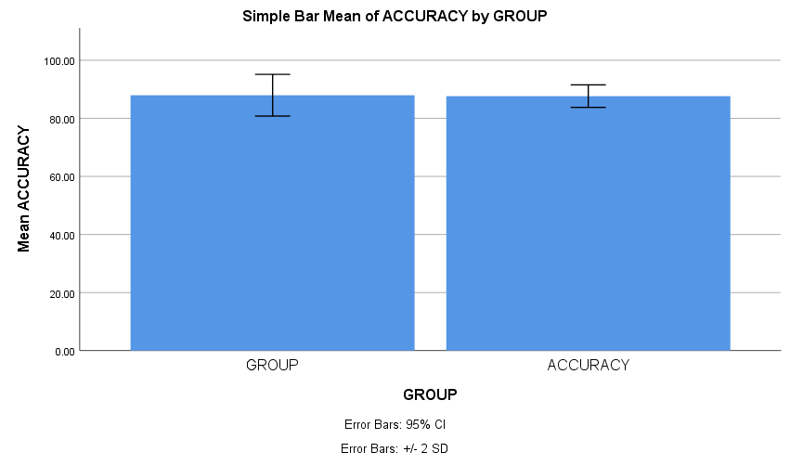

TITLE 2: TABLES AND GRAPHS

|  |  |  |  |  |  |
| --- | --- | --- | --- | --- | --- |
| **Group Statistics** | | | | | |
|  | GROUP | N | Mean | Std. Deviation | Std. Error Mean |
| ACCURACY | LSTM | 10 | 87.9500 | 3.58802 | 1.13463 |
| LR | 10 | 83.6600 | 2.35900 | .74598 |

|  |  |  |  |  |  |  |  |  |  |  |
| --- | --- | --- | --- | --- | --- | --- | --- | --- | --- | --- |
| **Independent Samples Test** | | | | | | | | | | |
|  | | Levene's Test for Equality of Variances | | t-test for Equality of Means | | | | | | |
| F | Sig. | t | df | Sig. (2-tailed) | Mean Difference | Std. Error Difference | 95% Confidence Interval of the Difference | |
| Lower | Upper |
| ACCURACY | Equal variances assumed | 1.082 | .312 | 3.159 | 18 | .005 | 4.29000 | 1.35789 | 1.43717 | 7.14283 |
| Equal variances not assumed |  |  | 3.159 | 15.556 | .006 | 4.29000 | 1.35789 | 1.40470 | 7.17530 |

TITLE 3: TABLES AND GRAPHS

|  |  |  |  |  |  |
| --- | --- | --- | --- | --- | --- |
| **Group Statistics** | | | | | |
|  | GROUP | N | Mean | Std. Deviation | Std. Error Mean |
| ACCURACY | GROUP | 10 | 86.7900 | 3.73138 | 1.17997 |
| ACCURACY | 10 | 80.8000 | 2.87866 | .91031 |

|  |  |  |  |  |  |  |  |  |  |  |
| --- | --- | --- | --- | --- | --- | --- | --- | --- | --- | --- |
| **Independent Samples Test** | | | | | | | | | | |
|  | | | | | | | | | | |
|  | | Levene's Test for Equality of Variances | | t-test for Equality of Means | | | | | | |
| F | Sig. | t | df | Sig. (2-tailed) | Mean Difference | Std. Error Difference | 95% Confidence Interval of the Difference | |
| Lower | Upper |
| ACCURACY | Equal variances assumed | .623 | .440 | 4.019 | 18 | .001 | 5.99000 | 1.49030 | 2.85900 | 9.12100 |
| Equal variances not assumed |  |  | 4.019 | 16.911 | .001 | 5.99000 | 1.49030 | 2.84448 | 9.13552 |

TITLE 4: TABLES AND GRAPHS

|  |  |  |  |  |  |
| --- | --- | --- | --- | --- | --- |
|  | **Group** | **N** | **Mean** | **Std. Deviation** | **Std. Error Mean** |
| **Accuracy** | LSTM | 10 | 86.7900 | 3.58802 | 1.13463 |
| SVM | 10 | 83.1800 | 3.40222 | 1.07588 |

|  |  |  |  |  |  |  |  |  |  |  |
| --- | --- | --- | --- | --- | --- | --- | --- | --- | --- | --- |
|  | | **Levene’s test for equality of variances** | | **T-test for equality means with 95% confidence interval** | | | | | | |
| **f** | **Sig.** | **t** | **df** | **Sig. (2-tailed)** | **Mean difference** | **Std.Error difference** | **Lower** | **Upper** |
| **Accuracy** | **Equal variance assumed** | .148 | .705 | 2.261 | 18 | .036 | 3.61000 | 1.59682 | .25521 | 6.96479 |
| **Equal Variance not assumed** | 2.261 | 17.849 | .037 | 3.61000 | 1.59682 | .25317 | 6.96683 |

